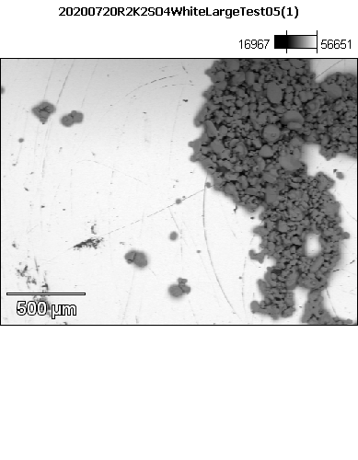

Data Type: Counts

Image Resolution: 512 by 384

Image Pixel Size: 4.50 µm

Map Resolution: 256 by 192

Map Pixel Size: 9.00 µm

Acc. Voltage: 12.0 kV

Magnification: 55

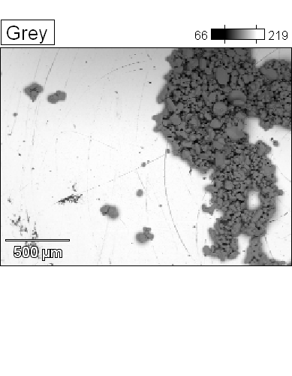 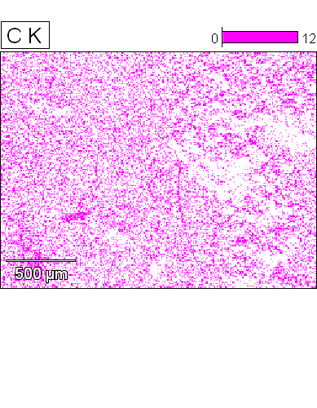



Data Type: Counts

Image Resolution: 512 by 384

Image Pixel Size: 4.50 µm

Map Resolution: 256 by 192

Map Pixel Size: 9.00 µm

Acc. Voltage: 12.0 kV

Magnification: 55

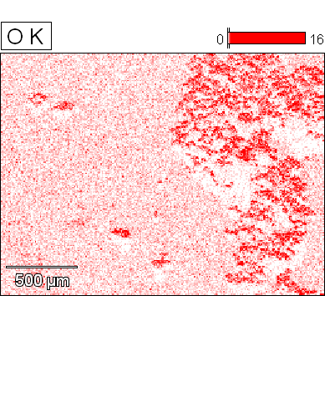 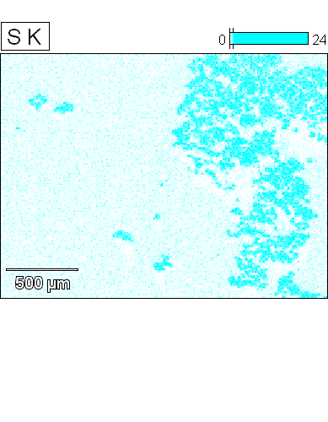



Data Type: Counts

Image Resolution: 512 by 384

Image Pixel Size: 4.50 µm

Map Resolution: 256 by 192

Map Pixel Size: 9.00 µm

Acc. Voltage: 12.0 kV

Magnification: 55

